The following is a ‘how to guide’ for accessing IEPs and 504 Plans on Infinite Campus

Please note that there is a column labeled IEP. You should IGNORE this column. It would indicate an IEP if we used the IEP creation software developed by Infinite Campus.

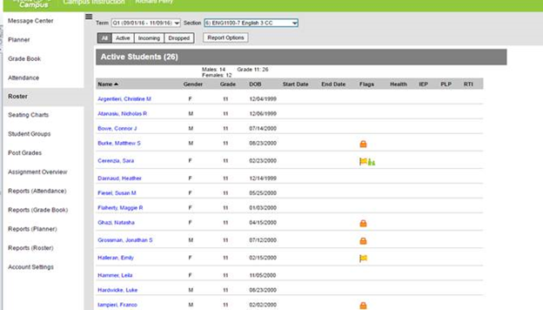

USE THIS INFORMATION – hover over to identify information (IEP, 504, special alert)
DISREGARD

The IEP and 504 information is in the system. Here’s the process for teacher access:

1. Under Flag column (orange flag = section 504 plan / orange lock icon = IEP Document), click on the appropriate student name

IEP

504 Plan

2. Click on to Student Information
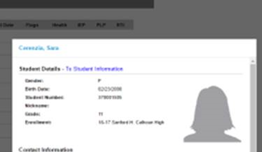
Student

3. Then click on Document:
Document
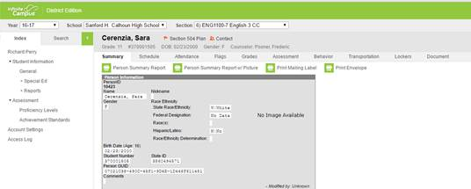
Student

4. Choose Document and select Get Document. IEP Direct will then open.
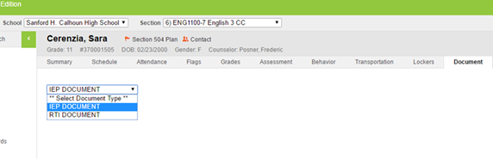
Student
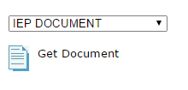
Select
Click
**Any questions or concerns, please feel free to call, email or stop by the Special Education office!
IEP ACKNOWLEDGEMENT THROUGH INFINITE CAMPUS
- Access your roster
- Click the name of your classified students (they have a lock next to them)
- Click Student Information (if you right click student info you can choose to open it in a new window. When you are done with the signature you can easily x out, instead of having to go back and start over)
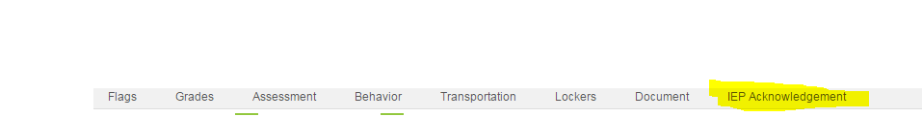
- Chose the IEP Acknowledgement Tab (upper right hand side)
- Click the green box titled- New Status
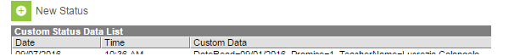

- Follow the prompts:
  - I have read the student IEP
  - Enter your name
  - The date read (on or before 9/5/17)- the status date is the date you acknowledged, you do not need to change it
  - SAVE
If you opened a new window, you can then x out and start with your next student.

